**Scope Document**

**Introduction**

The program is designated to aid DSC Travel Agency with managing their finance from aiding clients to book flights. The program is to be done by retrieving flight information from KAYAK, and retrieving airport information from World Airport Codes. Not to mention, all client data and the like are stored in a local SQLite database. All booked flights are paid through credit card, and airports will respond to their code by their generated E-Ticket number. The program allows for users to check all previous flight summaries of theirs as well.

**Stakeholders and End Users**

The end users of the program are mainly the clients and manager. The client has the benefit of booking a flight with ease, while the manager may maintain and calculate financial statistics with ease.

**Resources**

All resources for this project include online and local resources for the management of client and flight information. All flight information and the like are retrieved online from KAYAK and World Airport Codes. The only local resource used is the SQLite Database for storing of client information.

**Project Details**

The entire project will take over the period of 2 weeks, with milestones being that the first week will finish the Implementation and Test Case stages. The project will be following the Iterative Waterfall Cycle, where iterations will be done if any stage is yet to be filled.

**Time Table**

**Requirements**

A program to help my customer to:

* Login system, username based on numbers.
* Book flights in different classes (economy, premium economy, business, first class).
* Collect reward points (travelling points)
* ~~Book a hotel room~~
  + ~~room cost~~
  + ~~room type (president suite, double bed, single bed) kind of hotel, categorize hotel by stars, first day of stay, when the customer leaves)~~
* ~~Offer packages to customer~~
  + ~~Tour Packages: fly to Beijing and get 5 star hotel for free days, fly with Dragon Airline Business Class and get 3 nights of hotel.~~
    - ~~Pay deposit first, rest 1 week later.~~
    - ~~Cancelable.~~
* ~~Rent a car~~ 
  + ~~Types of cars: Family cars, vans, sport cars.~~
* Vouchers (bills, receipts, plane tickets)
* Payment Method (credit card)
* Manager Panel
  + 20% commission.
  + ~~Cancel transactions~~
  + Financial statistics

* All crossed out requirements have been removed by the client.

**Design**

* MVC Pattern
* BeautifulSoup Library Integration
* HTMLParser Python Library
* Login system based on Unique ID.
* SQLite Database
* PyQT GUI Library
* Manager Finance Management

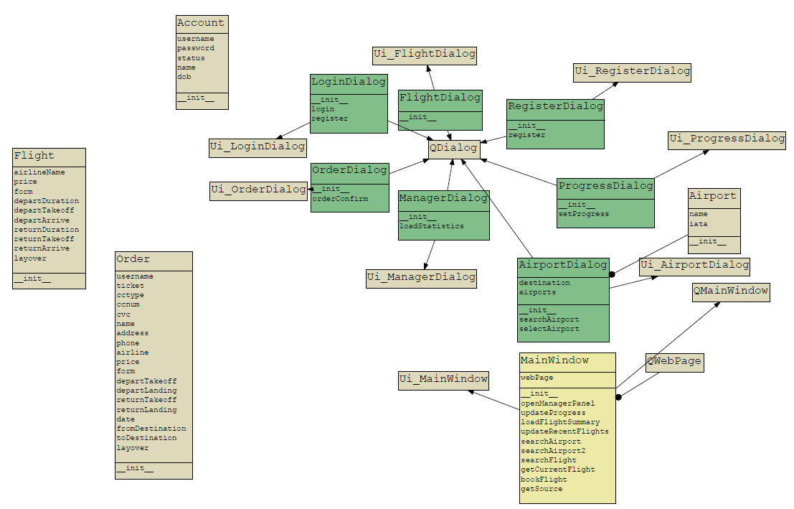

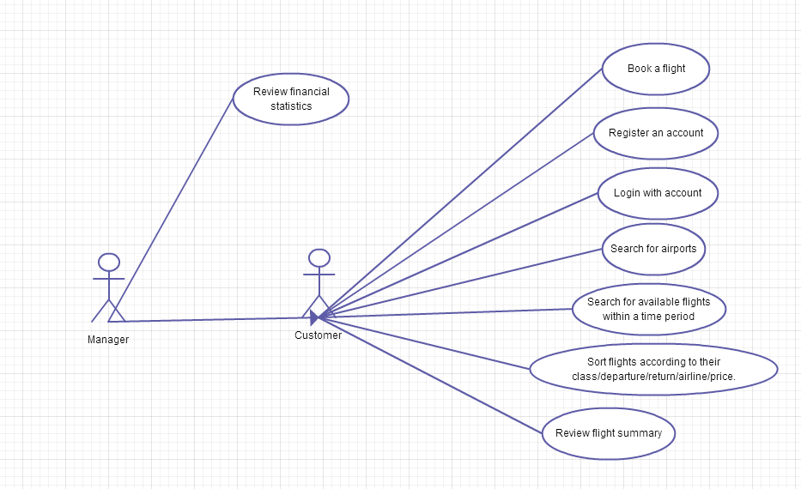

**Unit Test Document**

1. Airport Search
   1. Inputted in an airport name, and made checks for invalid airport names as well. All test cases involving airport name validity, and online airport database querying worked as expected.
2. Account Registering
   1. Inputted client name and password, and an unique User ID was copied into the system’s clipboard as expected. Cases of there being no input were taken into consideration as well.
3. Account Login
   1. Inputted User ID and password, and an user-friendly welcome message being shown as a result. Main window was shown afterwards, and error cases for invalid User ID/password taken into consideration. Shows error message if any error cases such as invalid User ID occur.
4. Flight Search
   1. After selecting a From/To destination, the program accurately sends a HTTP GET request to Kayak in order to request for available flights within a discerned time period. All HTTP data is interpreted correctly through the use of BeautifulSoup, and all data is correctly parsed into a table widget on the main window. Error cases in terms of there being no flights available or a lack of specifying input were taken into consideration and parsed just fine.
5. Sort Flights
   1. Clicking a table header on the flight results table on the main window sorts out the results just fine according to column. All sorting is done via PyQT’s table sorting algorithm.
6. Review Flight Summary
   1. Double clicking any recent flights entry on its respective table on the main window opens the review flight summary. Ticket ID and any important flight info are shown on a new window. No error checks are necessary in discern to this.
7. Flight Booking
   1. Filling out the order confirmation dialog and confirming an order presents the user with the flight summary, while providing them flyer mile points. Tests have been done to ensure of error cases indicating invalid input in the order dialog, and no logical errors have been found as a result. In case of any errors from the user’s side of input, an user friendly message is displayed indicating invalid input.

**System Test Document**

After testing the program on several computers containing the runtimes for PyQT’s libraries alongside Python’s environment, the program definitely deems itself to be completely successful. In order to ensure that the program met all requirements while functioning correctly, a test case was done to the program. A client was registered in the program’s respective register window, and then the client was logged into the program. During the registration process, the client had also attempted to register and login with invalid details, only proving to fail while providing an user-friendly message in return. The main window presented a list of their recent flights which led to be empty due to the fact that the client was entirely and newly generated.

Afterwards, an airport search from Hong Kong to Manila was condoned, with no problems occurring whatsoever. Attempts to produce error cases were done by specifying invalid/non-existent airport names, which were successfully handled. Afterwards, a flight search was done with all results being placed into respective search result tables on the main program. If no flights were available, an error message was given to the user to refine their search terms/conditions.

Once a flight was selected, the client is able to book the flight by inputting in their billing and payment information and confirming their order. If any of the fields were left blank, the user would be filed with an error. Afterwards, their flight information and ticket information would be available in the Recent Flights table on the main window once successful.

If the client that logged in is a manager, the manager would have the option to delve into all transaction data and financial info of the travel agency itself. This was done by manually elevating the access level of a client account into a manager account, and logging in to open the manager panel. The manager panel shows all transaction info available in the database along with calculated financial statistics such as income properly in format.

**User Manual**

Simply register an account on the login window of the program by inputting your real name and desired password and birth date. Afterwards, login and press the ‘Search’ button on respective To/From destination fields on the main screen in order to select the following airports for your flight.

Once you have selected the airports, select your requested takeoff and return dates and press ‘Search Flights’ in order to search for flights according to your search terms. Select your desired flight, and feel free to sort through the results by pressing on a specific data column on the search results table. Afterwards, press ‘Book Flight’ and fill out your payment information and billing information and confirm your order.

After your flight is booked, head to your Recent Flights list on the main window and double click any one of them to retrieve your E-Ticket Number. Enjoy your flight!

**Project Closure**

To conclude the entire product, after all the test cases done, no errors appear to be found from the program. In addition, all due dates have been met accordingly. Any errors that may occur from the user’s end is countered by an user-friendly message. All requirements have been kept according to the Use Case Diagram in the Design Document of the program, and all classes have been modelled according to the Class Diagram of the program. In order to aid the client with using the travel agency program, an user manual has been provided as well with thorough instructions on booking a flight.

